Department of Computing

Syed Muhammad Dawoud Sheraz Ali-111417

BESE-5B

**Lab 6: City Search Part 2**

**Date: April 5th, 2017**

**SE312: Software Construction**

**Instructor: Fahad Ahmed Satti**

**Lab Engineer: Ms. Maryam Sajjad**

**GitHub:** <https://github.com/SyedDawoud/University/tree/master/Software%20Construction/Labs>

# Introduction

This lab is an extension of lab 5, where we implemented the City Search using Hibernate. In this lab, we are going to make the model better by using the separate entities for Country, Cities and Areas. Also, we are going to use annotations to carry out the tasks for this lab. Another features is that in previous lab, user was given 5 nearby cities to search. Here, there is no such restriction. Instead, user will explicitly tell how many neighboring cities should be provided.

# Approach & Analysis

The basic approach followed is to store the data inside database. First task is to model the Country, City and Location classes. When these classes have been created, we use the sessions to store the data in the database created accordingly. When this is done, the next step is to implement functionality. For getting the longitude and latitude, the simple step is to take city name and query the database using Hibernate Query Language (HQL). Next task is to find the neighboring cities, given the city name or longitude and latitude. This has been done using the Great Circle Distance formula, which is:

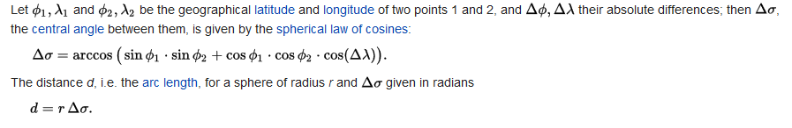

Source: <https://en.wikipedia.org/wiki/Great-circle_distance>

# Running the Code

This application requires the installation of the Hibernate. It must be setup before code can be used.